

**THE UNIVERSITY OF TEXAS AT ARLINGTON, TEXAS  
DEPARTMENT OF ELECTRICAL ENGINEERING**

**EE 5356**

**DIGITAL IMAGE PROCESSING**

**PROJECT # 3**

**by**

**SOUTRIK MAITI**

**1001569883**

**Presented to**

**Dr. K.R.RAO**

**Feb 22, 2019**

**Color Transformation**

*MATLAB Code:*

%%Open the RAW image

raw_img = fopen('girl256color.raw','r');

%%Read the RAW image

img = fread(raw_img);

%%vector for the Red component

R_img = reshape(img(1:3:length(img)),256,256)';

%%vector for the Green component

G_img = reshape(img(2:3:length(img)),256,256)';

%%vector for the Blue component

B_img = reshape(img(3:3:length(img)),256,256)';

%%Reconstruct image from RGB components obtained above

recon_img(:,:,1) = R_img;

recon_img(:,:,2) = G_img;

recon_img(:,:,3) = B_img;

%%Display original image

figure(1)

imshow(uint8(recon_img));

title('RAW Image');

%%Display RGB components

figure(2)

subplot(3,3,1)

image(uint8(R_img));

title('Red Component')

subplot(3,3,2)

image(uint8(G_img));

title('Green Component')

subplot(3,3,3)

image(uint8(B_img));

title('Blue Component');

%%Color Transformation Phase

%%We seperate out the YUV components using the following formulas

%%Y component

Y = 0.299 * R_img + 0.587 * G_img + 0.114 * B_img;

%%U component

U = (B_img - Y) / 2.03;

%%V component

V = (R_img - Y) / 1.14;

%%Display YUV components

subplot(3,3,4)

image(uint8(Y))

title('Y Component');

subplot(3,3,5)

image(uint8(U))

title('U Component');

subplot(3,3,6)

image(uint8(V))

title('V Component');

%%Inverse transformation Phase

%%We seperate out the Yd Cb Cr components using the following formula

%%Yd component

Y_d = 219 * Y + 16;

%%Cb component

C_b = (112 * (B_img - Y) / 0.889) + 128;

%%Cr component

C_r = (112 * (R_img - Y)/0.701) + 128;

%%Display the Yd Cb Cr components

subplot(3,3,7)

image(Y_d)

title('Yd Component');

subplot(3,3,8)

image(C_b)

title('Cb Component');

subplot(3,3,9)

image(C_r)

title('Cr Component');

*RESULTS:*

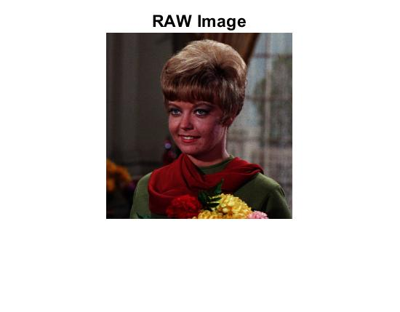

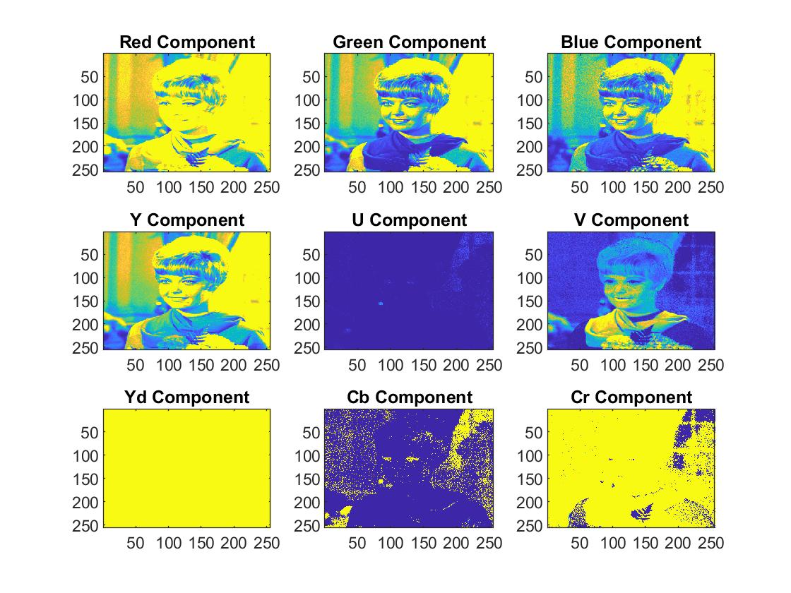

*MATLAB Code explanations (Conclusion):*

* Fopen is used to open the image and fread is used to store it in the form of vector.
* Reshape function is used to get the RBG components of the image.
* The corresponding transformations of YUV and YCbCr are obtained using the formulae.